**Laboratory 10 - Event Tree Analysis**

*(to be completed in Lab - Individually)*

**Exercise #1**

A stage coach makes a weekly run from Hangman's Hill to Placer Gulch, a distance of 180 miles. There are four way stations along the route, spaced at distances as shown in figure 1. The stage can travel no more than 85 miles without a change of horses, and it must not make rest stops between stations. Horses are changed at the stations at every opportunity. However, marauding desperadoes frequently raid the stations, driving off the stock, thus preventing the change of horses.

Troops have been garrisoned at Fort Buffalo Breath, near Station 4, and are dispatched to protect the four stations from marauding desperadoes. Their presence has resulted in the probabilities shown below that, at each of the way stations, there will be no horses upon arrival of the stage coach.

|  |  |
| --- | --- |
|  | Probability of No Horses |
| Stations 1, 2, and 3 | 0.2 |
| Station 4 | 0.1 |

Simplifying Assumption

Ignore all potential sources of system failure other than presence/absence of fresh horses at the way stations.

Problem

1. Develop an event tree for the system, showing all possible combinations of horses present/absent at each of the stations. *Use a separate sheet of Engineering Graph Paper.*
2. What is the probability that the stage coach will fail to reach Placer Gulch on a weekly run, owing to inability to change horses at a way station?
3. Would redeployment of troops improve system performance?

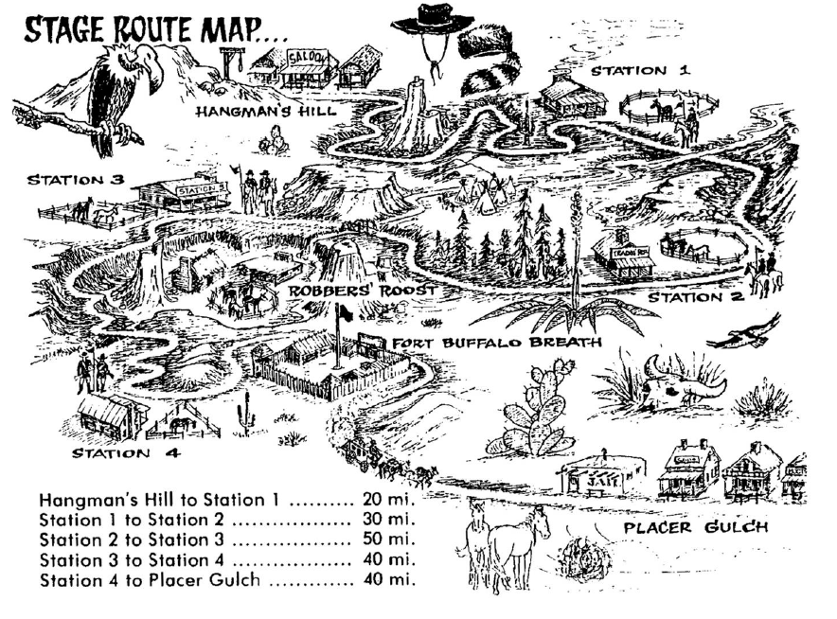

Figure 1

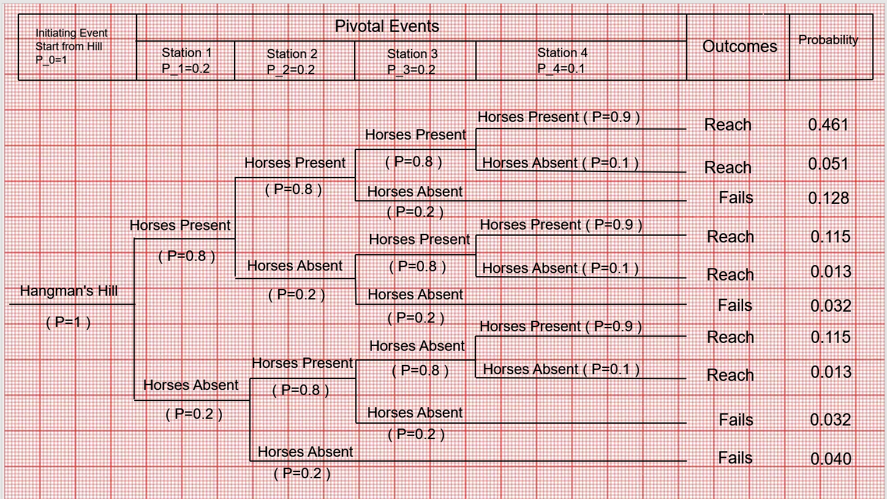

*Figure 1*

**b. The probability that the stage coach will fail to reach the Placer Gulch is**



**c. Would redeployment of troops improves system performance?**



**Exercise #2**

Consider the anti-flooding system shown in figure 2. A subgrade compartment containing important control equipment is protected against flooding by the system show. Tsing Floodwater will close float switch S, powering Pump P from an uninterruptible power sully. A Klaxon alarm horn K sounds to alert operators to perform manual bailing B should pump P fail. Pumping or bailing will dewater the compartment effectively.

Assume the following:

* Flooding has commenced (Pf = 1.0)
* Battery Power is available full time
* Only four system components (S, P, K and B) should be considered
* Operator error is included with bailing function

1. Develop an Event Tree representing system responses – *Use a separate sheet of Engineering Graph Paper.*
2. Calculate the probability of each consequence using the following probability data:

* PFS = 0.80
* PFP = 0.65
* PFK = 0.15
* PFB = 0.50

*图表

*

**So the probability of A is P(A)=0.070**

**So the probability of B is P(B)=0.055**

**So the probability of C is P(C)=0.055**

**So the probability of D is P(D)=0.020**

**So the probability of E is P(E)=0.800**

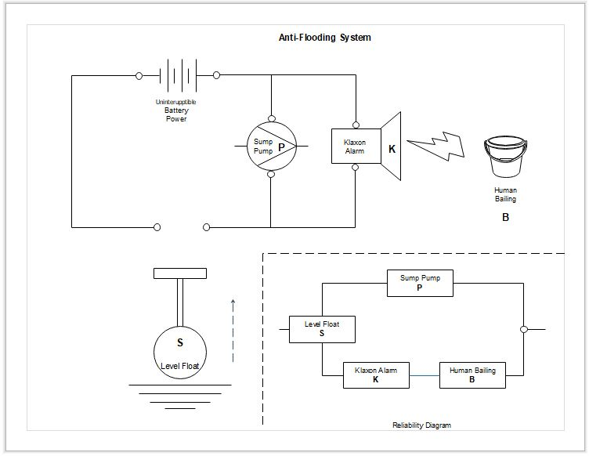

Figure 2